**Dartmouth DIFUSE**

ENGS93 Module

Installation Tutorial Handout

Author: Ben Levesque

Contact: benjamin.d.levesque.24@dartmouth.edu

*Note:* The video tutorial and these instructions assume you have downloaded [Anaconda](https://docs.anaconda.com/anaconda/install/index.html) and Anaconda Navigator, and that you have seen the original instructions video. Please ensure these are downloaded before continuing. Additionally, these instructions are primarily intended for Mac users, but a Windows user could follow the same steps: the only difference is when we open the “terminal” on Windows, we open Anaconda Prompt instead.

**Video Instructions:**

For the video paired with these instructions, click [here](https://youtu.be/rUcPrHpI6bg).

**Step 1 :: Create a Virtual Environment in Python 3.8.16**

* Open Anaconda Navigator, and enter the Environments panel
* At the bottom of the list of environments, click “Create”
* Create a new environment (perhaps named “engs93”), and select ***Python 3.8.16*** as the version of Python and click the checkmark box next to R (version doesn’t matter for R)
* Be patient, twiddle your thumbs, this will take 1-2 minutes.

**Step 2 :: Install the Extension Package (with Minor Fix)**

* Mac Users: Open Terminal
* Windows Users: Open Anaconda Prompt (a terminal specifically for interacting with Anaconda)
* We have a couple steps here, so I’ll provide all of the command’s we’ll be using. You’ll input these commands **one at a time**, waiting after each step until you see the prompt (i.e. you see the words “done” or “finished” and you are able to type into the terminal again.

| ***In the Terminal / Anaconda Prompt:*** |
| --- |
| conda activate ENVIRONMENT_NAME  conda install -c conda-forge jupyter_contrib_nbextensions  cp /Users/USERNAME/anaconda3/envs/ENVIRONMENT_NAME/lib/python3.8/site-packages/nbclassic/static/components/marked/lib/marked.umd.js /Users/USERNAME/anaconda3/envs/ENVIRONMENT_NAME/lib/python3.8/site-packages/nbclassic/static/components/marked/lib/marked.js  conda deactivate |

Note: You ***must replace USERNAME and ENVIRONMENT_NAME*** with the name of the user (in the video, it’s b-thayer) and the name of the environment you created in step 1 (in the video, it’s engs93). conda activate engs93

[Skip to Step 3 if you don’t need context] For context, these lines of code do the following:

* Activate the virtual environment, whose name is ENVIRONMENT_NAME
* Install the jupyter_contrib_extensions package into the activated virtual environment
* Copy the contents of the marked.umd.js file into a file named marked.js (bug fix)
* Deactivate the virtual environment

**Step 3 :: Install Jupyter Notebook 6.3.0**

* Close the Terminal / Anaconda Prompt, and navigate to the “home” pane in Anacoda Navigator
* At the top, ensure that the environment you created is selected. If your environment name is “engs93”, it should look like this:

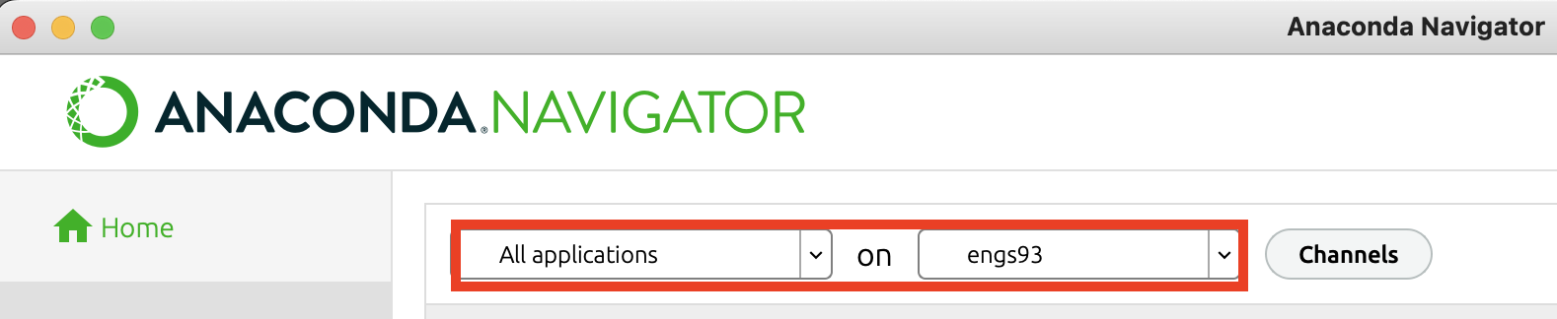

* Next, click the little gear in the Jupyter Notebook tile, hover over Install Specific Version, and install version 6.3.0

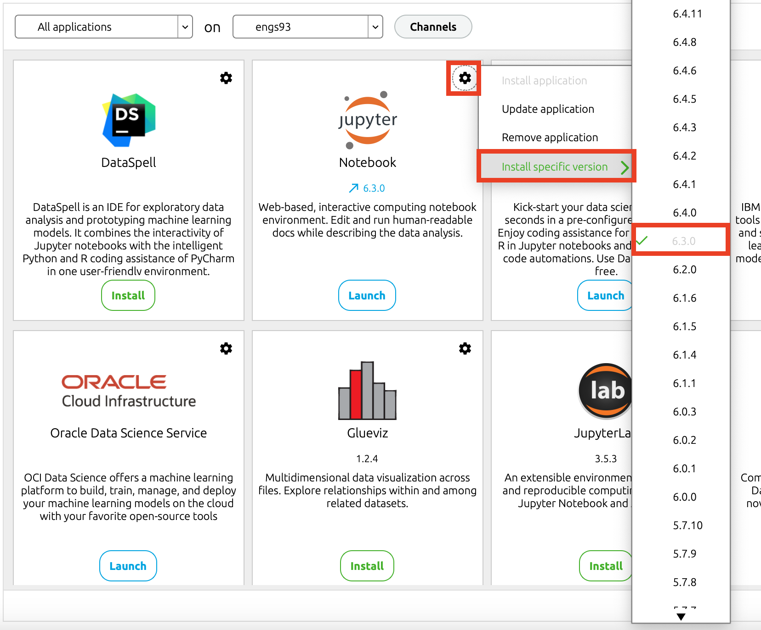

* Wait a moment, sip your coffee. You’ll know the installation is done when the blue loading bar at the bottom of Anaconda Navigator has disappeared.

**Step 4 :: Open Jupyter Notebooks, Enable Extensions, Open the Assignment**

* We’re going to open Jupyter Notebooks from Terminal (for Mac users) / Anaconda Prompt (for Windows users), so open your terminal and input the following commands:

| ***In the Terminal / Anaconda Prompt:*** |
| --- |
| conda activate ENVIRONMENT_NAME  jupyter notebook |

* Your browser should open with Jupyter Notebooks, and you can go to the Nbextensions tab to enable **Exercise2, Table of Contents, and highlighter**.
* Next, go back to the Files tab and navigate to the assignment. I recommend using RX1_HW to check that everything’s running smoothly. ***WAIT FOR THE KERNEL TO START***, and be sure to click the “Trust” option in the top right and say that you trust the notebook file.
* Once the kernel has started (and the little dot next to the letter R is empty/white), you can run the first cell by clicking it and pressing CMD + Return. You should see a few values calculated below, and you’re officially set up!